Devin Hardy

Dhardy2@my.athens.edu

00076619

Database Report

This report is to discuss the possibility of upgrading the way spreadsheet data is currently being utilized. This upgrade is the creation of a database that will centralize the spreadsheet data that is currently scattered or duplicated. That data saved in this manner will allow for easier access and better management. Which would allow the agency to have better data retrieval over its operations while also providing the ability for future growth.

**Data Dictionary**

The following tables are detailed descriptions over where and how the data is going to be stored. The data stored in this manner will allow for easier retrieval or manipulation of the database. This keeps the database ever expanding allow the future growth mentioned before.

This table is about the resumes from potential workers that the agency receives. Collecting all the information needed such as contact information, education, work history, references, availability, and skills.

**PWorker**

|  |  |  |  |  |
| --- | --- | --- | --- | --- |
| Data Name | Data Type | Length | Description | Source |
| Name | Character | 20 | Name of the Potential Worker | PWorker |
| SNN | VarChar | 11 | Social Security Number | PWorker |
| Address | VarChar | 30 | Mailing Address | PWorker |
| Telephone | VarChar | 12 | Phone Number | PWorker |
| AltNumber | VarChar | 12 | Alternate Phone Number | PWorker |
| Education Level | Character | 20 | Highest Level of Education | PWorker |
| Institute | Character | 20 | Institution of Education | PWorker |
| Year Granted | VarChar | 4 | Year Graduated | PWorker |
| PrevWorkTitle | Character | 20 | Previous Work Title | PWorker |
| PrevWorkTelephone | VarChar | 12 | Previous Work Number | PWorker |
| ReferenceName | Character | 20 | Name of Reference | PWorker |
| ReferenceNumber | VarChar | 12 | Number of Reference | PWorker |
| DateAvailable | VarChar | 8 | Date of Availability | PWorker |
| TimeAvailable | VarChar | 5 | Days Available to work | PWorker |
| Skills | Character | 30 | Skills | PWorker |

This next table gathers the data after the Personnel Director holds an interview with any candidates that might join the workforce.

**PersonnelDirector**

|  |  |  |  |  |
| --- | --- | --- | --- | --- |
| Data Name | Data Type | Length | Description | Source |
| InterviewDate | VarChar | 8 | Date of Interview | PersonnelDirector |
| IntName | Character | 20 | Name of Interviewee | PersonnelDirector |
| JobType | Character | 20 | Type of Job | PersonnelDirector |
| JobLevel | Character | 10 | Level of Job | PersonnelDirector |
| StartDate | VarChar | 8 | Start Date of Work | PersonnelDirector |
| Rejection | Character | 50 | Reason for Rejection | PersonnelDirector |
| DaysAvailable | Character | 30 | Days Available to work | PersonnelDirector |
| HoursAvailable | VarChar | 10 | Hours Available to work | PersonnelDirector |

This table will hold every client that has asked for assistance from the agency. It collects the name and contact info of every client that has asked for help.

**Employer**

|  |  |  |  |  |
| --- | --- | --- | --- | --- |
| Data Name | Data Type | Length | Description | Source |
| Name | Character | 20 | Name of the Client | Employer |
| Telephone | VarChar | 12 | Telephone Number | Employer |

The following table will hold every job from clients. It lists what the job is and the level of experience required for the job.

**Job**

|  |  |  |  |  |
| --- | --- | --- | --- | --- |
| Data Name | Data Type | Length | Description | Source |
| JobTitle | Character | 20 | Job Title | Job |
| JobLevel | Character | 10 | Job Level | PersonnelDirector |
| DailyRate | Float | 6 | Pay amount Per day | Job |
| Skills | Character | 30 | Skills needed for Job | PWorker |
| EduLevel | Character | 10 | Education Level | PWorker |
| Hours | VarChar | 10 | Hours of work | Job |
| ClientName | Character | 20 | Client Name | Employer |
| ClientNumber | Character | 12 | Client Phone Number | Employer |

This next table holds the data after one of the workers is matched with a job and has an interview with a client.

**WCInterview**

|  |  |  |  |  |
| --- | --- | --- | --- | --- |
| Data Name | Data Type | Length | Description | Source |
| Wname | Character | 20 | Name of the Worker | PWorker |
| CName | Character | 30 | Client Name | Employer |
| Date | VarChar | 8 | Date of the Interview | WCInterview |
| Time | VarChar | 5 | Time of the Interview | WCInterview |
| Outcome | Character | 10 | Outcome of the Interview | WCInterview |
| StartDate | VarChar | 8 | Start Date of Work | WCInterview |
| EndDate | VarChar | 8 | End Date of Work | WCInterview |

This table holds the evaluations from clients after either a successful or terminated job. This should reduce the need for two separate forms.

**Evaluation**

|  |  |  |  |  |
| --- | --- | --- | --- | --- |
| Data Name | Data Type | Length | Description | Source |
| wName | Character | 20 | Name of the worker | PWorker |
| cName | Character | 20 | Name of the Client | Employer |
| JobTitle | Character | 20 | Job Title | Job |
| EvalDate | VarChar | 8 | Evaluation Date | Evaluation |
| Rating | Interger | 1 | Rating of the Worker | Evaluation |
| Comment | Character | 50 | Comment After the Evaluation | Evaluation |

The billing information is described here. This should allow easy retrieval of the data making the accounting manager’s job less stressful.

**Bill**

|  |  |  |  |  |
| --- | --- | --- | --- | --- |
| Data Name | Data Type | Length | Description | Source |
| ClientName | Character | 20 | Name of the Client | Employer |
| DailyRate | Float | 7 | Daily Rate of Pay | Job |
| JobTitle | Character | 20 | Job Title | Job |
| Days | Integer | 3 | Days of Pay | Bill |
| Hours | Integer | 3 | Hours of Pay | Bill |

This would hold the payroll data. It would assist on making accounting less stressful as well. It will also assist on gathering tax related information what it is required.

**Payroll**

|  |  |  |  |  |
| --- | --- | --- | --- | --- |
| Data Name | Data Type | Length | Description | Source |
| WorkerName | Character | 20 | Name of the Worker | PWorker |
| GrossPay | Float | 5 | Gross Pay | Payroll |
| TaxesWithheld | Float | 4 | Taxes Withheld | Payroll |
| NetPay | Float | 5 | Net Pay | Payroll |
| YtDateHours | Integer | 4 | Year to Date Hours | Payroll |
| YtDateGrosspay | Float | 7 | Year to Date Gross Pay | Payroll |
| YtDateTaxes | Float | 6 | Year to Date Taxes Withheld | Payroll |
| YtDateNetPay | Float | 7 | Year to Date Net Pay | Payroll |

**Cross Reference**

The data dictionary described how the data would be stored. These next two tables reference the previous tables to show what forms and reports they will assist on filling out from the stored data from the database.

**Forms Table**

This table covers which forms are filled from what database medium. The ‘X’ marks if data is retrieved from that corresponding dictionary.

|  |  |  |  |  |  |  |  |  |
| --- | --- | --- | --- | --- | --- | --- | --- | --- |
| Names | PWorker | PersonnelDirector | Employer | Job | WCInterview | Evaluation | Bill | Payroll |
| Worker Application Form | X |  |  |  |  |  |  |  |
| Personnel Director Interview Form | X | X |  |  |  |  |  |  |
| Job Requisition |  |  | X | X |  |  |  |  |
| Worker Evaluation Form |  |  |  |  |  | X |  |  |

**Report Table**

This covers which reports are cross referenced from the data dictionary. This one is also marked with an ‘X’ for each dictionary that correspond with information needed in a report.

|  |  |  |  |  |  |  |  |  |
| --- | --- | --- | --- | --- | --- | --- | --- | --- |
| Names | PWorker | PersonnelDirector | Employer | Job | WCInterview | Evaluation | Bill | Payroll |
| Weekly Client Bill |  |  | X |  |  |  | X |  |
| Weekly Pay Stub | X |  |  |  |  |  |  | X |
| Weekly Payroll Report |  |  |  |  |  |  |  | X |
| Client Account Receivables Report |  |  | X |  |  |  | X |  |
| Worker Jobs Report | X |  | X |  | X | X |  |  |
| Report of Current Assignments | X |  | X | X |  |  |  |  |
| End-of-Year Wage and Tax Statement |  |  |  |  |  |  |  | X |

**ERD**

**This is an Entity Relationship Diagram it represents what tables have data related to another it is connected to.**

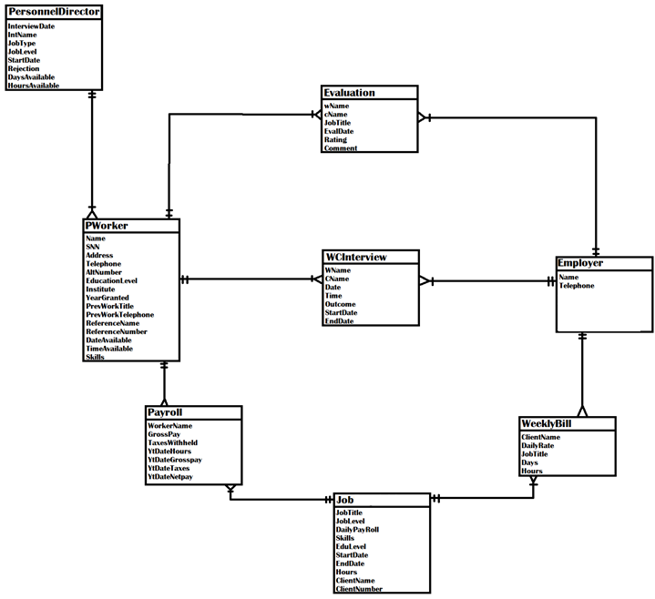**EERD**

**This small Diagram is just an enhanced version of the previous one showing that the Job table can be split into either a Professional or a Clerical Position.**

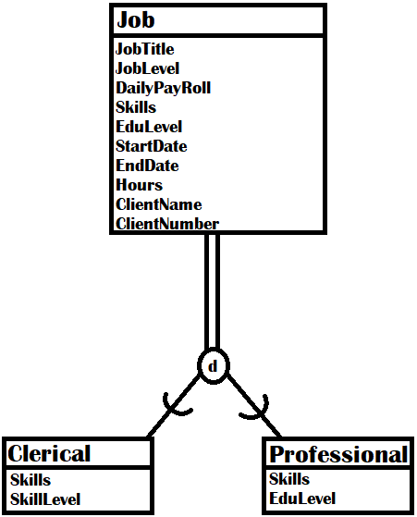

**Reference Page**

[1] D. Holland, *Finding the Building Blocks of Wood*, The University of Melbourne, June 6, 2018. Accessed on: June 13, 2018. [Online]. Available: <https://pursuit.unimelb.edu.au/articles/finding-the-building-blocks-of-wood?utm_source=linkedin.com&utm_medium=social&utm_content=story>